**What you need:**

* 1 river rock
* Wire – 20 gauge or smaller
* Beads
* Pen or marker (not supplied)
* Pliers (optional; not supplied)

**Rock & Bead Photo Holder**

|  |  |
| --- | --- |
| 230 | 5 |

*Note: photos are for instructional use; your finished product will have 2 spots for photos instead of 4.

**What to do:**

1. Cut a strip of wire 18-24” long.

(This step has been done for you ☺)

1. Tightly twist the wire around the rock,

holding in place so the rock won’t slip out.

1. Bring wire to the top center and twist together. Try to keep the bottom centered and the wires as tight against the rock as possible.
2. Twist about ½” up from the rock, tightening with pliers if needed.
3. Add beads in any order/design, leaving about 2-3” free at the ends.
4. Once beads are on, wrap each wire end around a Sharpie or pen at

least 2 times. Remove Sharpie and squeeze these loops together to create a tight spot to stick a photo or memento.

1. Add photos to display!

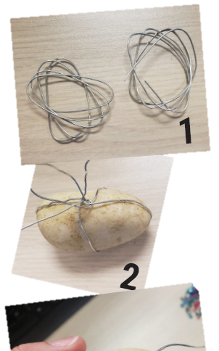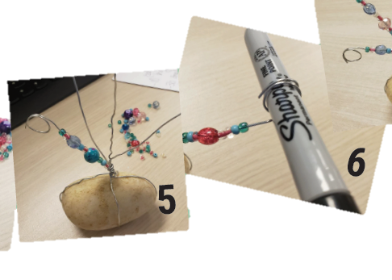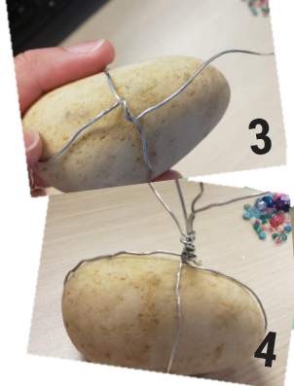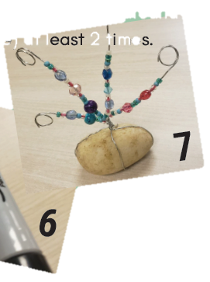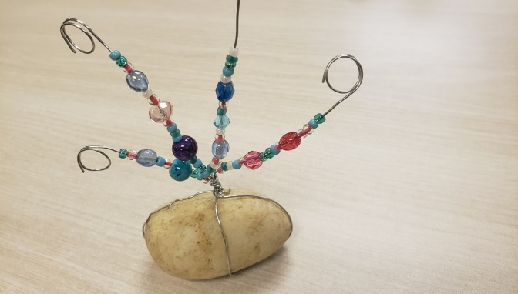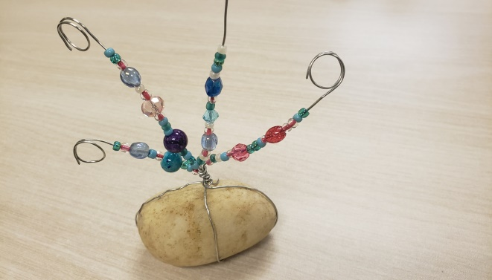

**\***Optional ideas:

* Add decorative details

to the rock base—have fun with paint, Sharpies, jewels, etc.

* Use extra wire for a 3-4 photo holder.